**Shreeram Saini**

**RA2011042010125**

**Package Diagrams**

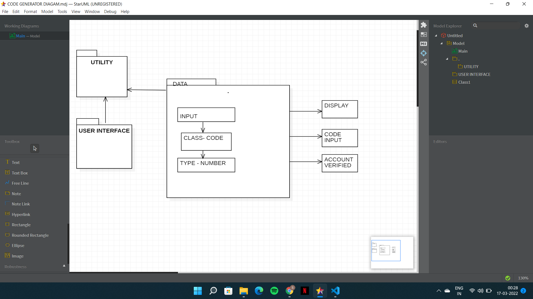

Package diagrams are used to structure high level system elements. Packages are used for organizing large system which contains diagrams, documents and other key deliverables.

* Package Diagram can be used to simplify complex class diagrams, it can group classes into packages.
* A package is a collection of logically related UML elements.
* Packages are depicted as file folders and can be used on any of the UML diagrams.

As we can see package diagram in above figure. In the figure, we can send code in mail is function call and div function attribute is also use like email verification.